This project consists of two microservices:

1. **user-service**: Handles user registration and retrieval.
2. **user-client-service**: Retrieves user details from ***user-service*** using FeignClient

**Technologies Used**

* Java 17
* Spring Boot 3.5.0
* Spring Web
* Spring Data MongoDB
* Spring Validation
* Lombok
* Feign Client
* JUnit & Mockito
* Maven

**Project Structure**

**user-service**

Modules:  
- model.User – Defines the User entity.  
- controller.UserController – Exposes REST endpoints for user registration.  
- service.UserService – Contains business logic.  
- repository.UserRepository – Interacts with MongoDB.  
- model.ValidUserProperties – Loads validation properties from config.  
- exception.GlobalExceptionHandler – Handles custom exceptions.  
- exception.UserNotFoundException – Thrown when user is not found.

**User-client-service**

Modules:  
- feign.UserClient – Feign interface to call User Service.  
- controller.ClientController – Client-facing endpoints.  
- model.User – DTO for user data.

**REST API Endpoints**

**1. user-service**

* **POST /register**

Registers a new user.

**URL:** [**http://localhost:8080/register?city=Paris**](http://localhost:8080/register?city=Paris)

* **Request Body:**

{

  "name":"Reshma",

  "age": 25,

  "country":"France"

}

* **Success Response:**

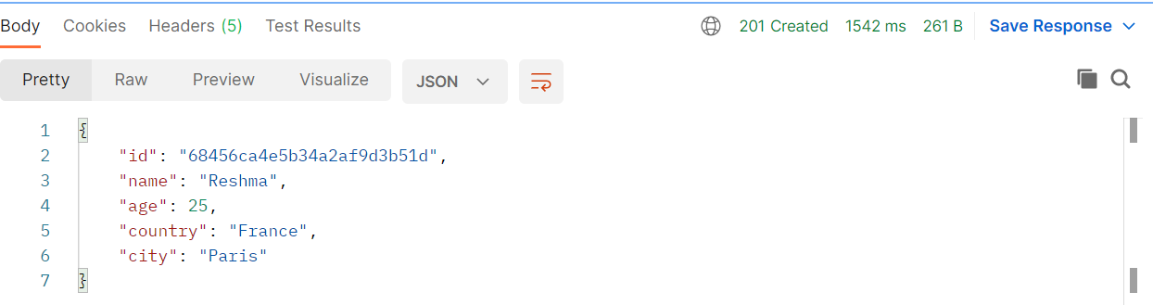

* **Error Response (age < 18 or country != France):**

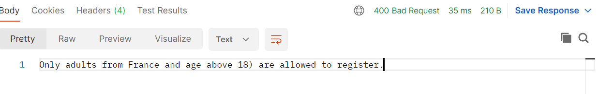

**2. user-client-service**

* **GET :**

**URL:** **http://localhost:8081/client/user/68456e15e5b34a2af9d3b51e**

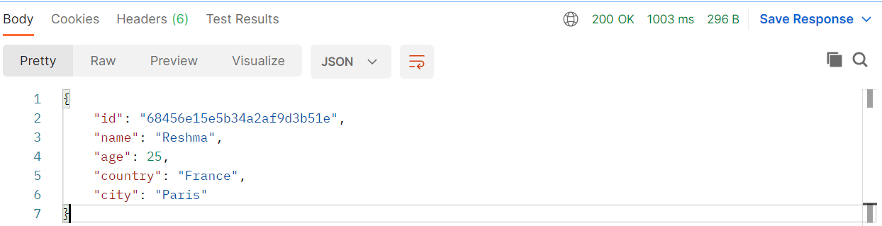

* **GET**

**URL: http://localhost:8081/client/users**

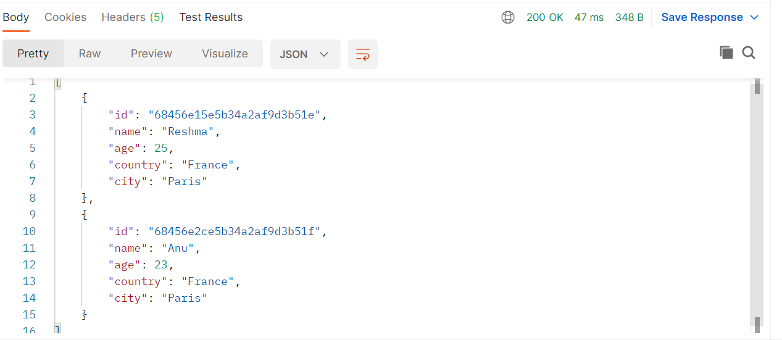

**Configuration Notes**

* **User validation rules are configured in application.properties under keys:**
* **user.allowed.age**
* **user.allowed.country**
* **Feign client uses @FeignClient(name = "user-service") and requires proper base URL config.**